**Activity 4.7**

**Using the Python IDLE**

Write your own summary sheet to describe how to run python programs including how to save and open .py files. Include any other commands that you have found useful.

|  |  |
| --- | --- |
| **Using the Python IDLE** |  |
| How to open a new window | Ctrl + N |
| How to save a file | Ctrl + S |
| How to open a file | Ctrl + O |
| How to run a program | Ctrl + R OR F5 |
| How to undo/redo | Ctrl + Z (UNDO) / Ctrl + SHIFT + Z (REDO) |
| How to replace a section (highlighted area) | Ctrl + H |
| How to find a section | Ctrl + F |
| **Useful tips** |  |
| alt p | Displays the last line you entered |
| Commands in the file are not colour coded | Save as a .py file |
| F6 | Allows you to view the last shell |
| Ctrl + SHIFT + S | Allows you to choose where to save |

**Activity 5.1**

**Where does the name “Boolean” come from?**

Boolean variables are named after George Boole who invented the mathematics of digital logic. Find a picture of George Boole and insert it here. When was he born? 2nd Nov. 1985



**Activity 5.2**

**Finding the data type:** Use the “type” function to find out the data types for these values.

>>>type("Fred") -<class 'str'> - string

>>> type(198) - <class 'int'> - integer

>>> type(88.9) - <class 'float'> - number with a decimal

>>>type(True) - <class 'bool'> - Boolean

>>>type(False) - <class 'bool'> - Boolean

*Remember that True and False must start with a capital letter.*

**Activity 5.3**

The type function returns the data type of an expression.

For each of the following expressions predict the data type then use the type command to check your prediction.

|  |  |  |  |
| --- | --- | --- | --- |
| **expression** | **Predicted data type** | **Type command** | **Result** |
| “hello world” | String | type("hello world") | <class ‘str’> |
| False | Boolean | type(False) | <class 'bool'> |
| 15 | Integer | type(15) | <class ‘int’> |
| 35.6 | Number with a decimal | type(35.6) | <class ‘float’> |
| -999 | Integer (just has a – before it, it’s still a whole number) | type(-999) | <class ‘int’> |
| “15” | String or Integer | type(“15”) | Error |
| “False” | Boolean or String | type(“False”) | Error |
| True | Boolean | type(True) | <class ‘bool’> |
| 0.001 | Number with a decimal | type(0.001) | <class ‘float’> |

**Activity 5.4**

The interactive shell is a useful place to explore variables. Write code to ask users for the following information. *Hint – use input*

Create a variable called myName and assign it to your name.

Create a variable called myAge and assign it to your age

Create a variable called myEyes and assign it to your eye colour.

Create a variable called myHeight and assign it to your height.

Write the commands to display on the screen your name, age, eye colour and height.

Write a descriptive print line that includes all the information recorded from the variables

**Activity 5.5**

**Variable names**

A programmer is trying to decide which would be a valid name for a variable which represents a house number.

Which of the following variable assignments are valid? Why are the others not valid?

|  |  |  |
| --- | --- | --- |
|  | **Valid or invalid variable name?** | **Reason why not valid** |
| 8HouseNumber = 288 |  |  |
| houseNumber = 288 |  |  |
| house Number = 288 |  |  |
| house_number = 288 |  |  |
| import = 288 |  |  |

**Activity 7.4**

This program asks if it is snowing and if so tell you to take a sledge otherwise to have a good day. The condition is missing.   
  
Copy and complete the condition to make the program work correctly.

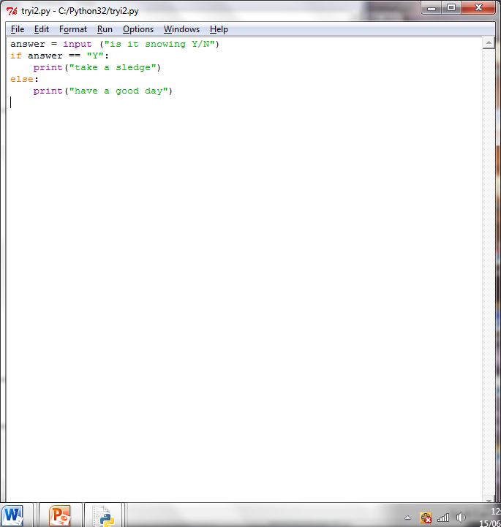

answer == “Y”:

**Activity 7.5**

What condition is needed in this program to display “pass” if the exam mark is greater than 40?  
Copy and complete the condition to make the program work correctly.

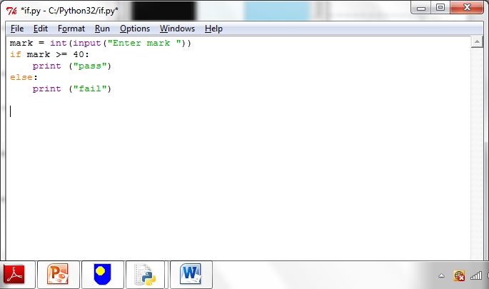

mark >= 40: